
ABE 2.0: PTC Lab Protocol

Overview

In this laboratory you will explore the connection between your genetics (genotype) and your observed characteristics (phenotype) using taste perception. During a subsequent activity, you will be given an opportunity to taste the compound phenylthiocarbamide (PTC). Upon tasting PTC you will experience one of these three phenotypic reactions: a strong bitter taste, a mild bitter taste, or nothing at all.

The population studies conducted by chemist Arthur L. Fox in the 1930s revealed that the ability to taste PTC is an inherited dominant trait that varies in the human population and influences how we taste PTC. The gene that encodes for the PTC taste receptor, TAS2R38, was identified in 2003. Taste receptors are found on the surface of some of the cells on our tongue and we know today that TAS2R38 encodes for one of the thirty taste receptors that allow detection of bitter­tasting compounds.

Metabolizing our foods begins with breaking them down as we chew. Chemical compounds within the foods will either bind or not bind to taste receptors on the cells of our tongue. If a compound binds to a receptor, this results in activation of the receptor, in which a signal is transmitted to our brains, allowing us to perceive taste.

The TAS2R38 gene has a dominant and a recessive version (allele). Each allele encodes a different version of the PTC taste receptor, and differences in perception of taste are based on which alleles an individual carries. The goal of this laboratory is to determine your genotype using multiple molecular biology techniques. These steps are outlined in Figure 1 (page 2) and described in Table 1 (page 3).

First, you will use Polymerase Chain Reaction (PCR) to amplify (make many copies of) a short region of the TAS2R38 gene. Figure 3 (page 7) outlines the steps of PCR. In order to differentiate between the TAS2R38 alleles, the amplified PCR product will be digested (cut) with the restriction enzyme HaeIII. Restriction enzymes cut at specific DNA sequences, termed recognition sequences. The HaeIII recognition sequence will allow us to distinguish the single­n ucleotide polymorphism (SNP) that differentiates the PCR products of the dominant and recessive TAS2R38 alleles. The PCR product of the dominant allele will be cut by the enzyme, while the PCR product of the recessive allele will not, as shown in Figure 1 (page 2). This means that differently sized fragments will be produced for homozygous dominant, homozygous recessive, and heterozygous individuals. Therefore, after the restriction digest with HaeIII, you will use gel electrophoresis to visualize your resulting fragments in order to conclude your genotype.

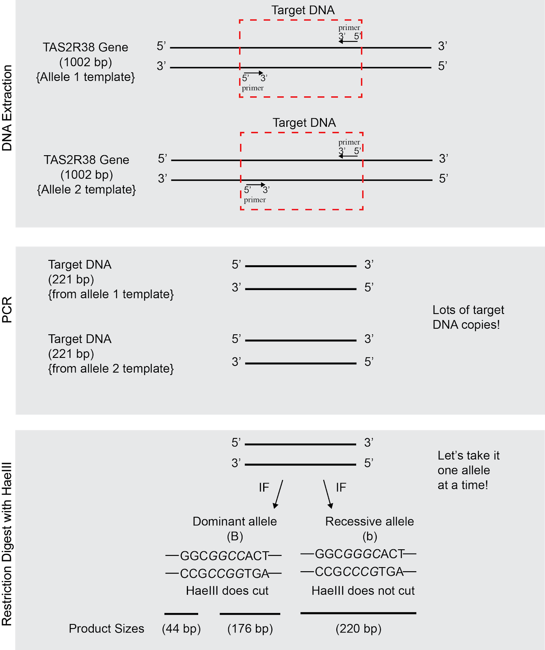

Figure 1: Overview of Laboratory Procedure
Figure 1. In this laboratory procedure, you will first isolate your own DNA from your cheek cells. We are interested in determining your genotype at the TAS2R38 locus. Therefore, we will use primers that have been designed to specifically amplify a portion of the TAS2R38 gene using PCR. Figure 3 (page 7) outlines the three key steps in PCR that allow us to make billions of copies of our target DNA. We need this many copies in order to first perform a restriction digest using HaeIII to differentiate between the dominant and recessive alleles, and then finally to visualize these resulting fragments using gel electrophoresis.

Protocol Step | Starting Material | Ending Material | Purpose
DNA Extraction | Your cheek cells | Your DNA | Obtain your DNA from the nuclei of your cheek cells
Polymerase Chain Reaction | Your DNA | >106 copies of TAS2R38 target DNA (220bp) | Produce lots of copies of TAS2R38 fragment for analysis
Restriction Digest with HaeIII | 220bp­length target DNA copies | Allele­specific cut and/or uncut DNA fragments | Differentiate dominant and recessive TAS2R38 alleles using HaeIII
Gel electrophoresis | Allele­specific cut and/or uncut DNA fragments | Differently sized bands on an agarose gel | Visualize cut and/or uncut DNA fragments to determine your genotype
Table 1: Protocol Outline

Protocol

Collecting and Isolating DNA from Your Cheek Cells

You will be extracting DNA found in the nuclei of your cheek cells. These cells can be easily collected by gently swabbing the inside of your mouth with a toothpick. You will transfer your cheek cells by twirling the toothpick in a tube containing Chelex® beads. Chelex® is a chelating (binding) agent that is often used for DNA extraction. In order to isolate your DNA, we must break down the cellular and nuclear membranes. We will do this by boiling your cheek cell samples. Once these membranes are broken down, components normally in the cytoplasm have access to the DNA. These components include enzymes called DNases that break down DNA. DNases require metal co­factors for activity. The Chelex® resin will bind these metal co­factors away from the DNases, thereby inhibiting DNase activity.

  - You will receive 100µL of Chelex® beads in a small, green 0.2mL tube. Clearly label the top and side of this tube with your initials using a permanent waterproof marker. You labeled your tube as:

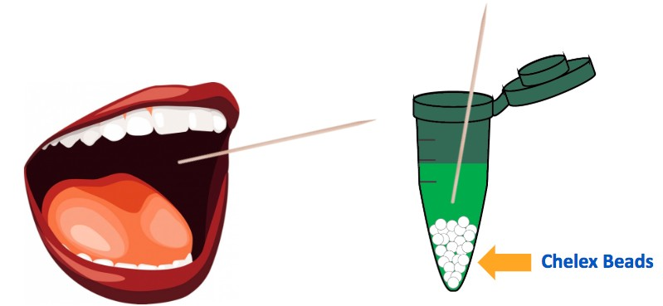
  - Using the broad or flat end of a sterile toothpick, gently swab the inside of your mouth for at least 30 seconds.
Figure 2: DNA collection and extraction procedure

  - Swirl the toothpick in the tube of the Chelex® beads for at least 30 seconds to dislodge the cells and cap the tube tightly. Place used toothpick in waste container.

  - Create a program on the thermocycler to hold a temperature of 99°C for 10 minutes. Name this “DNA Extraction Heat Block”.

  - Place your 0.2mL green tube into the thermocycler. Close the lid and run “DNA Extraction Heat Block”.

  - Once the DNA Extraction Heat Block protocol is finished, allow your teacher to remove your tubes from the thermocycler carefully so that the Chelex® beads at the bottom are not disturbed.

Amplifying PTC DNA by PCR

In human cells, DNA replication results in two identical copies of the entire human genome. PCR is a molecular biology lab technique that allows us to replicate a small portion of DNA that we are interested in (the “target DNA”). As you may imagine, it would be terribly difficult to find and work with only two tiny fragments of DNA isolated from one individual’s DNA. Instead, we can use PCR to locate, isolate, and make (“amplify”) millions of copies of a gene from one person. In this case, you will use PCR to isolate and amplify your own PTC gene.

A PCR reaction contains:
- Source DNA from one person (from your cheek cells!)
  - Provides a template for DNA polymerase to read
- Taq DNA polymerase
  - Bacterial enzyme that allows DNA replication at high temperatures
- Primers
  - Molecular “post­it notes” that define target DNA
    - One per each strand of DNA (forward and reverse)
  - Short DNA fragments (18­22 base pairs) that we design
  - Bind to target DNA through complementary base pairing
- dNTPs
  - Deoxynucleotide building blocks (A, T, C, G) used to make new strains of DNA
- Salts and buffers
  - Ensure correct chemical conditions for reaction
  - Includes MgCl2 which is a co­factor required for Taq DNA polymerase activity

Steps of a PCR reaction (refer to Figure 3, page 7 for diagrams of each step) The “chain” reaction of PCR is composed of three steps: denaturation, annealing and extension.
  - Denaturation (94°C)
    - Hydrogen bonds that hold DNA together are broken, therefore DNA is separated (“denatured”) into single strands
  - Annealing (64°C)
    - Primers bind to single strands of template DNA
  - Extension (72°C)
    - Taq DNA polymerase creates a new strand of DNA starting at the end of each primer

These three steps constitute one synthesis cycle during which the number of copies of DNA doubles. A reaction with 35 cycles will therefore produce over a billion copies.

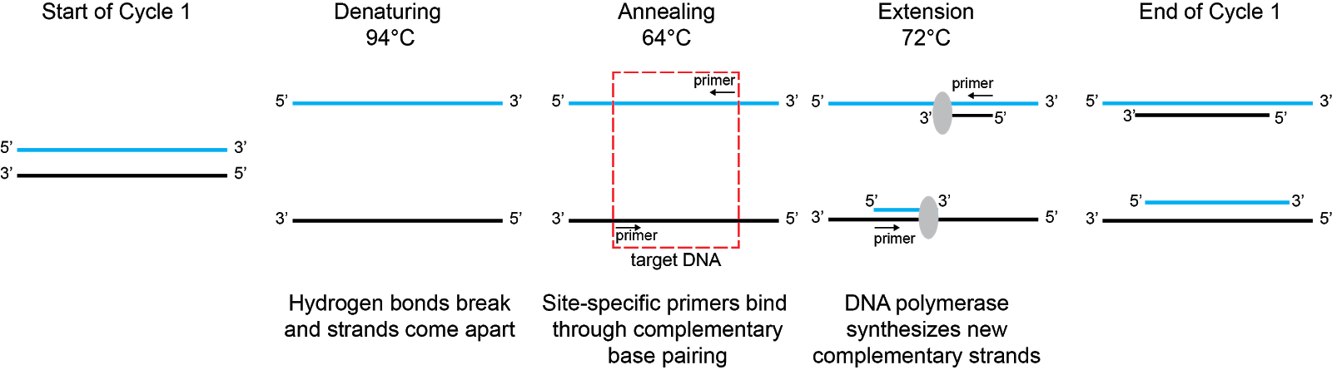

Figure 3: Steps of a PCR reaction

At the end of the first cycle of PCR you will have 4 strands (2 original template strands, 2 newly synthesized strands). Draw out the steps that occur during the second cycle below. How many strands will you have at the end of cycle 2?
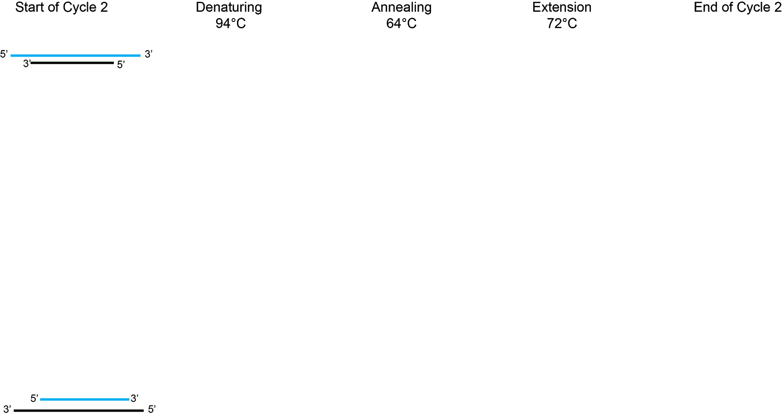

Stop and Think
At which cycle of the PCR reaction will you have amplified a fragment of just the target sequence?

- Carefully pipette 2.5µL of the supernatant, which contains your DNA, to the 0.2mL clear PCR tube that already contains the TAS2R38 Primer Master Mix. Label the tube with an asterisk* and your initials. This tube now contains everything you need in order to run a successful PCR reaction (template DNA, TAS2R38 primers, and a standard master mix). Centrifuge your sample for 30 seconds in the adapters to pool reagents and store it on ice until ready to begin the reaction.
The PCR Master Mix includes:
- OneTaq® DNA Polymerase
- TAS2R38 specific primers
- dNTPs (A, T, C, G)
- Salts (Tris­HCl, KCl, NH4Cl, MgCl2) pH 8.9

- Program your thermocycler by creating a new PCR protocol, following the temperature and time specifications below. Name this protocol “PTC PCR Program”.

 | Step | Temperature | Time
 | Initial Denaturation | 94°C | 300 seconds
 | Denaturation | 94°C | 30 seconds
Repeat 35 times | Annealing | 64°C | 30 seconds
 | Extension | 72°C | 30 seconds
 | Final Extension | 72°C | 60 seconds
Table 2: PCR Cycle details

- When the program is finished, allow your teacher to remove your labeled tube from the thermocycler as it will be hot.

- Store your samples on ice or at 4°C until ready to begin the next part.

Restriction digest of PCR products with HaeIII

You have now amplified a portion of the TAS2R38 gene. PCR amplification will result in a DNA fragment 220 base pairs (bp) long. Recall that the TAS2R38 gene has a dominant and a recessive version, and that the two alleles can be differentiated by a
single­nucleotide polymorphism (SNP). In order to differentiate between a dominant and a recessive allele, we will perform a restriction digest on the PCR products using the HaeIII restriction enzyme. Restriction enzymes cut at specific DNA sequences termed recognition sequences. HaeIII recognizes a 5’ GGCC 3’ DNA sequence (refer to Figure 1, page 2). The dominant allele contains the 5’ GGCC 3’ recognition sequence and therefore will be cut by HaeIII. Note this sequence occurs on both strands when read from the 5’ to 3’ direction. This results in two fragments post restriction digest: 176 bp and 44 bp.The recessive allele lacks this recognition sequence and therefore will not be cut by HaeIII. This results in a 220 bp uncut fragment post restriction digest.
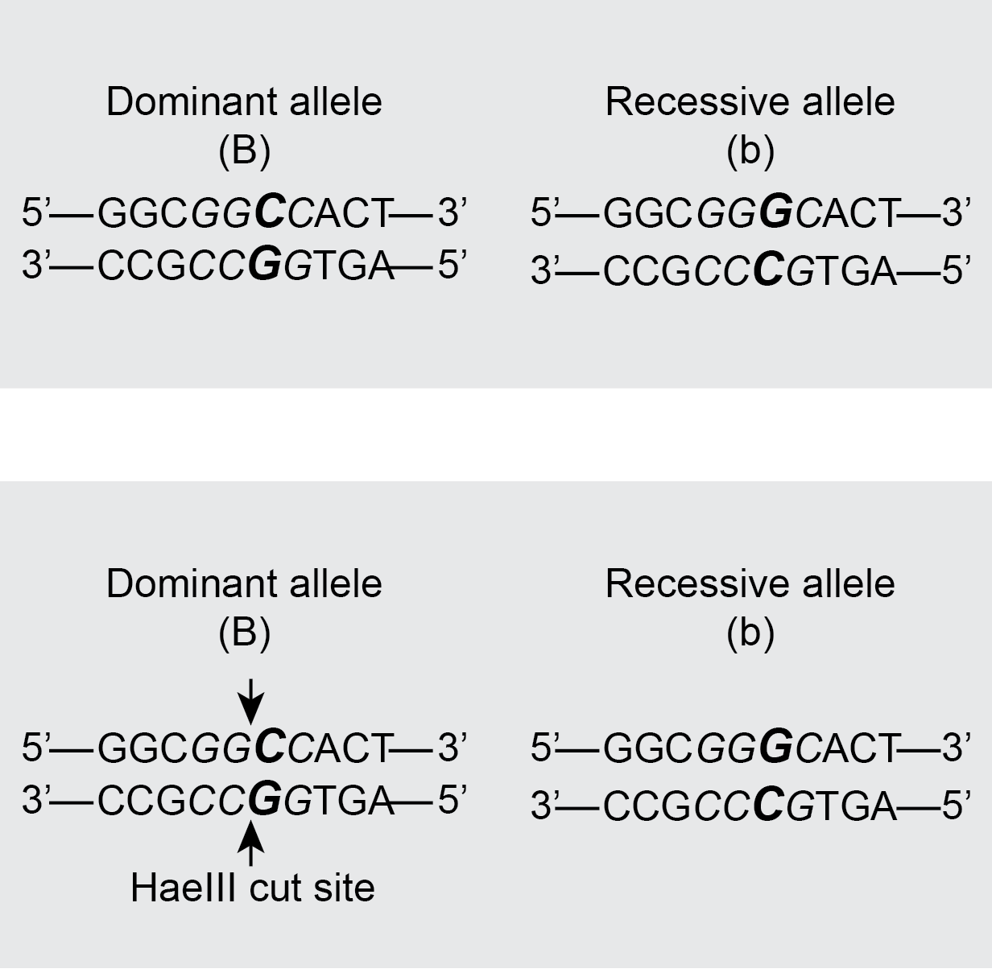

Based on this information, fill out Table 3 below and compare with your classmates.

Genotype | Allele 1: cut, uncut? | Allele 2: cut, uncut? | DNA fragment sizes
BB
Bb
bb
Table 3: Results of Restriction digest with HaeIII

  - Using a p10 or p20 micropipette, add 2µL of HaeIII restriction enzyme from the pink tube your teacher handed out into your PCR sample. You will be digesting your entire sample.

  - Gently pipette up and down 3­4 times to ensure that the enzyme mixes with your sample.

  - Centrifuge the PCR tubes for 30 seconds in the adapters to pool reagents.

  - Create a program on the thermocycler to hold a temperature of 37°C for 5 minutes. Name this “PTC Digest”.

  - Place your labeled clear tube back into the thermocycler for digestion. Close the lid run “PTC Digest”.

Gel Electrophoresis

After the restriction digest with HaeIII, the resulting DNA fragments will be separated on an agarose gel using gel electrophoresis.

Gel electrophoresis is a technique that uses an electrical current to separate biomolecules based on size and charge. Since all DNA is negatively charged (due to the phosphate groups in the sugar­phosphate backbone), gel electrophoresis will separate DNA fragments based on size. DNA is loaded into the wells of the agarose gel at the negative end (anode). Electricity is applied and as electrical current passes through the gel, the negatively charged DNA fragments move towards the positive end (cathode). An agarose gel is a porous matrix. Therefore, smaller DNA fragments will be able to move through the pores easier and travel faster. Larger DNA fragments will have more difficulty moving through the gel and therefore travel slower. As the sample progresses through the gel, the fragments sort into distinct bands based on their size.

Since we amplified billion of copies of our TAS2R28 gene in the PCR reaction, we should have sufficient DNA to visualize. The bands of DNA can be visualized by illuminating the gel with blue light. The gels have been prepared with SyberSafe®, a dye that attaches to DNA and fluoresces under UV light.

  - Add 2µL of colored loading dye to your PCR sample before loading it on the gel.

  - Your teacher will direct you to the gel sign up sheet. Sign up for a specific lane for which you will load your sample. Your teacher will load the 100bp ladder and the undigested control into the specific lanes that are noted on the signup sheet.

  - Load 20µL per your teacher’s instructions of your PCR sample into your assigned well. Gently depress the pipette button to the first stop to slowly expel the sample without introducing bubbles.

  - Run the gel as instructed (voltage and time). Depending upon your gel system, the gel will end on its own or you will need to stop the gel and notify your teacher that you have finished.

  - In Table 3 (page 9) you deduced for each genotype whether the alleles present would be cut or uncut and you further noted the fragment sizes. Using this information, for each genotype draw where the resulting fragments would be predicted to run on the gel and draw the bands on Figure 4 (page 12).

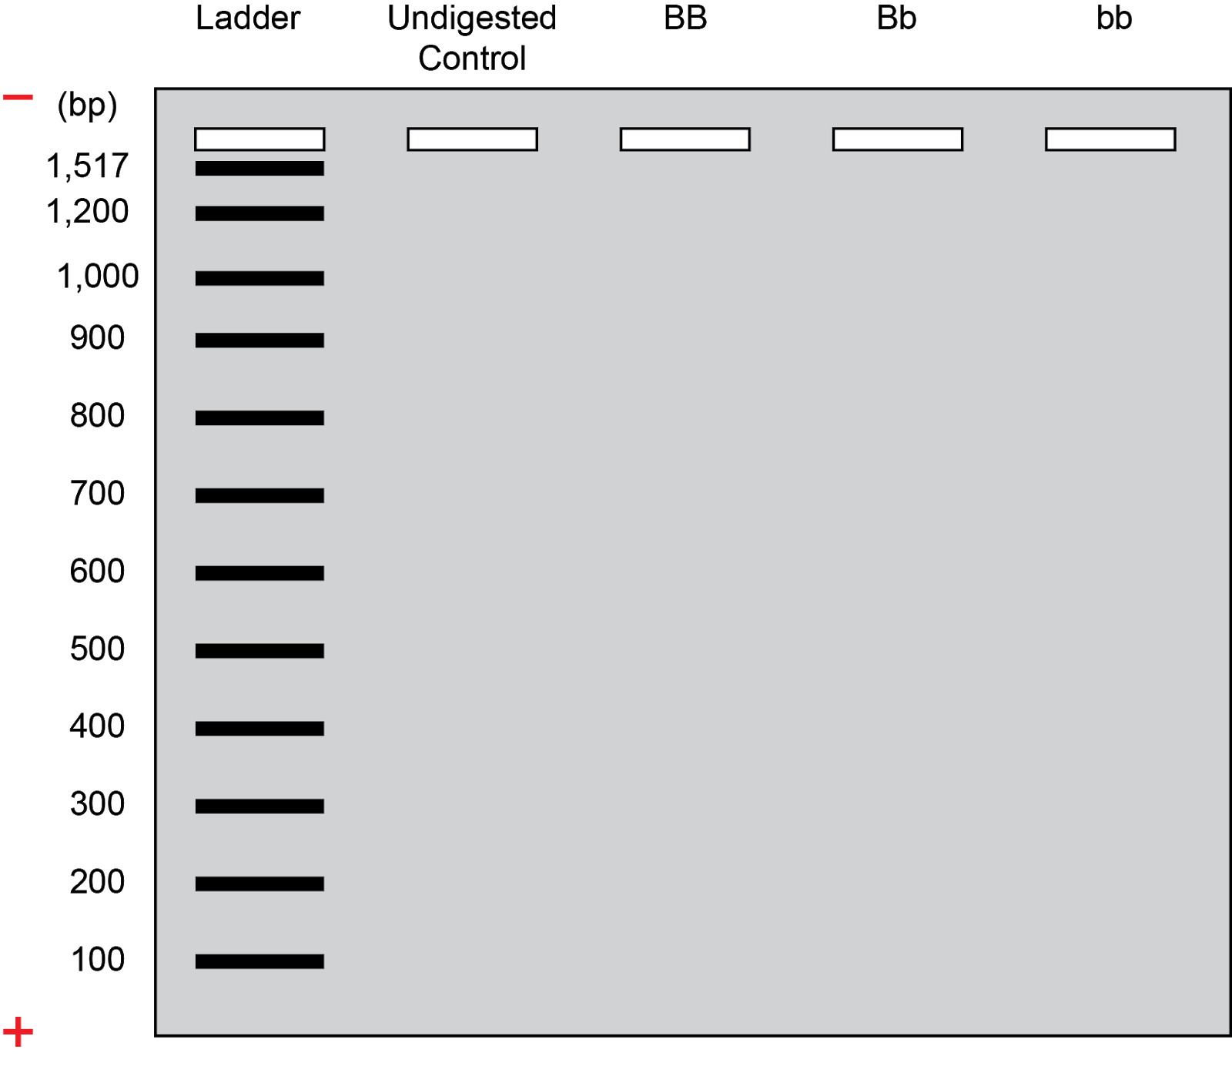
Figure 4: Predicted Gel Results for each tasting genotype

  - After your gel has finished running, you will visualize your bands. Draw your actual results in Figure 5 (page 13) and then compare with classmates for the other corresponding genotypes to complete the figure.
Figure 5: Actual Gel Results for each tasting genotype

